Preventing House Dust Mite Allergens in New Housing

Subrato Chandra, Ph.D. David Beal
Member ASHRAE
ABSTRACT
House dust mite allergens are a major cause of asthma. The objective of this study was preventing dust mite allergens in new houses with wall to wall carpets, NOT eradicating dust mites from infested homes.
Five pairs of homes, located in the southeastern USA, were studied for an average of 12 months. Each pair consisted of a newly built home with a central dehumidifier and an existing home without a central dehumidifier. Three new homes and 2 existing homes had thorough vacuum cleaning practices. Dust samples were taken monthly from a minimum of 4 locations in each home and analyzed for mite allergen levels. Carpet level relative humidities and temperatures were measured.
The dehumidification systems maintained the average carpet relative humidity (RH) below 60% in all 5 new homes for all months. The 3 new homes with dehumidification and thorough vacuum cleaning practices did not have any dust mite allergens at the beginning of the study and continued allergen free. The 2 new homes with a dehumidifier and the 3 existing homes with poor cleaning practices had high allergen levels. The 2 existing homes with thorough vacuum cleaning practices had high allergen levels on one occasion only.
INTRODUCTION
House dust mite allergens are a major cause of asthma in humid climates¹. In U.S. homes, carpets, mattresses and upholstered furniture are major reservoirs of mites². Current recommendations¹ to reduce allergen exposure are to encase mattresses and pillows and box springs; weekly washing of bedding with hot water (>55 ºC); and regular use of vacuum cleaners with allergen trapping features, such as dust bags with two layers, or whose exhaust air is ducted outside (central vacuums), or filtered with HEPA, or electrostatic filtration systems. Available data on the efficacy of vacuum cleaners indicate that while they reduce the allergen burden, they are unlikely to control exposure from carpets and furnishings¹. A 1982 study, presumably using vacuum cleaners with no allergen trapping features, found that vacuum cleaners had little effect in reducing mites in carpets³. A current recommendation¹ is to remove carpets from houses in humid climates. However, carpets are desired by many consumers. Thus, the present study was motivated by the need to eliminate dust mite allergens in houses with wall to wall carpets. Please note that the objective of this study is to prevent dust mite allergens in new houses which start off allergen free. The objective is NOT to eradicate dust mites from infested houses, a more difficult problem.
Laboratory studies of fasting female Dermatophagoides farinae dust mites indicate that their bodies continue to dehydrate when kept below 58% relative humidity (RH) at 25ºC or 52% RH at 15ºC⁴. Other dust mite species have higher RH requirements to prevent dehydration⁵. While dehydration does not necessarily lead to death, it reduces fecal and allergen production⁵.
Several studies have investigated the usefulness of dehumidifiers in reducing mite allergens. Cabrera et al. investigated the use of bedroom dehumidifiers in 10 houses in the humid Canary Islands⁶. Allergens were reduced significantly in the mattresses from bedrooms in 8 of the 10 homes, although the final allergen level was greater than 2 g/g of dust, considered relevant for asthma⁷, in 9 out of the 10 houses. Another study, conducted in the U.K., found that a single portable dehumidifier placed centrally in the house was not effective in reducing mite counts, when comparing data from six houses with dehumidifers and six control homes without dehumidification⁸. Niven et al. conducted a study in the U.K., using central dehumidifiers, and they also failed to find a positive benefit in terms of reducing mite allergens despite achieving control of temperature and humidity⁹. All these studies were done on existing, not new homes.
Thorough vacuuming should eliminate the food source for dust mites, and central dehumidification should control the relative humidity (RH) to below that required for dust mite mobility. As a result, new houses with negligible dust mite allergens should not experience an increase. The literature does not have data on the effectiveness of this combined strategy, the subject of this study.
METHODS
Description of monitored houses
Five pairs of homes, all with central cooling and heating systems, were investigated in four cities of the Southeastern U.S. Table 1 provides the details of the homes. Each pair of homes consisted of a new home with a central dehumidifier and an older existing home without a central dehumidifier. The existing homes differed from the new homes in many ways as shown in Table 1. The main benefit of studying the existing homes was to determine the level of dust mite allergens in typical homes without central dehumidification. The existing homes were located in the same city as the new homes, and the occupants agreed to participate in the study. The different types of vacuum systems and the frequency of vacuuming is indicated in Table 1. The dehumidification system was a whole house dehumidifier with a mechanical ventilation system. This system is installed next to the air handler and ducted to dehumidify the whole house. It is controlled by a dehumidistat so the RH inside the house can be controlled independent of the temperature. One new house, in New Orleans, initially used an energy recovery ventilation system with a desiccant wheel. The desiccant wheel in this system passively lowers the RH in the house when the outside air absolute humidity is lower than that inside the house. The homeowner chose to deactivate this system in mid June, 1997 and replace it with a mechannical dehumidification system, as described above, in August, 1997. The carpets installed in these new houses were of the conventional variety, with heat set Nylon filaments with a 1.3 cm pile height, except for the New Orleans house, which was made in the Berber style, with closed loop Nylon. The Jacksonville new house did not have wall to wall carpets, only area rugs.
Environmental monitoring
Each home was monitored on average for 12 months (minimum 8 , maximum 16 months). Interior temperatures and RH were measured at the carpet level by small battery powered data loggers, which recorded the instantaneous data every hour. The measurement uncertainty is estimated to be +/- 2.5% RH and +/- 0.5ºC.
Dust sample collection. Dust samples were collected in each home at a minimum of four locations – master bedroom mattress, master bedroom carpet in front of the bed, family room sofa, and the family room carpet in front of the sofa. For dust sample collection, the entire top surface of the mattress was vacuumed after removing the bed sheet. The entire surface of the sofa was also vacuumed for sample collection. Carpet dust samples were collected by vacuuming an area of approximately one m² for one minute. Dust samples were collected with a portable vacuum cleaner whose inlet was modified to accept a standard paper coffee filter which collected the dust. The paper filter was folded and taped and stored in separate air tight plastic bags and shipped to the laboratory for analysis. Dust sampling was performed by the same students in all Orlando area homes. The other homes were sampled by the homeowner who were each given a similar set of dust collection equipment and instructed in their use. Those homeowners were paid a small monthly fee for their cooperation whereas the Orlando area homeowners cooperated voluntarily. Dust samples were collected monthly during the study period.
Dust sample analysis. Analysis of the dust samples was performed by the same technician throughout the study. After receiving the dust samples in the laboratory, they were stored at 4ºC until analysis. Twenty-five mg were extracted at 1:40 w/v in 0.2 mM ammonium bicarbonate buffer, pH 9, overnight at 4ºC. The supernatant was isolated and filtered through a 0.45 m nitrate acetate filter. Der p1 and Der f1 allergen levels were measured by ELISA, according to the protocol described by Chapman et al.^{10,11}.
RESULTS
Figure 1 shows the measured RH and temperature data for the five existing homes. The data collected for each house is aggregated for each calendar quarter and displayed. Except for house #5, the summer time average temperature is close to 25ºC.
As all homes used central air conditioning, the average RH during the summer months ( second and third quarters of every year) are below or near 58% RH. During the winter months ( first and fourth quarters), the outside temperatures are lower and, as a result, the central air conditioner is not used much. Due to occupant activities and infiltration of outside humid air, the average carpet level RH for all existing houses during the winter quarters are higher than the summer quarters, while the average carpet level temperature goes down during the winter. This promotes dust mite growth in the winter months in the Southeastern U.S.
Figure 2 presents the measured allergen levels in the existing homes. Existing house #2 has an allergen trapping vacuum cleaner, but it is not used often. Consequently, the house has high allergen levels. Existing houses #4 and #5 have regular vacuum cleaners, and, despite frequent usage, have significant allergens. Existing house #1 has a central vacuum cleaner, which was used regularly. Despite not having a central dehumidifier, this house had low allergens for the first three quarters. Only in the last quarter of sampling (Q1'97), after a period of prolonged high humidity, the maximum allergen level in the living room carpet location exceeded the threshold value. In existing house #3, a housekeeper vacuumed two or three times a week with an allergen trapping vacuum cleaner. This house never had measurable allergens. However, due to lack of home owner cooperation, the sampling period did not last as long as desired. Existing house #1 and #3 indicate the dust mite control potential of thorough vacuum cleaning practices with a good equipment.
Figure 3 shows the measured carpet level RH and temperatures in the five new homes. Except for new house #2 in the last quarter, where the dehumidifier system was not ducted optimally, the average measured RH values are lower than 58%. The central dehumidification systems performed well in controlling the winter time humidity. The average temperatures are comparable to those in the existing homes.
Figure 4 presents the measured dust mite allergens. New house #1 had a regular vacuum cleaner, and, despite RH control, had significant dust mite allergens. The fact that this new house had high allergen levels is consistent with other studies^{6,8,9} which found that RH control alone was ineffective in controlling mite allergens.
New houses #2, 4 and 5 all had wall to wall carpets and thorough vacuum cleaning practices. The highest measured group 1 allergen level at any location in these three homes was only 1.04 g/gram of dust. Although the new house #3 did not have wall to wall carpeting, just area rugs, it had allergen levels occasionally exceeding the threshold value. It used a regular vacuum cleaner.
CONCLUSIONS
The results of this study show that thorough vacuuming (defined as at least twice weekly with an upright vacuum cleaner with an allergen trapping dust bag, or once weekly with a central vacuum cleaning system exhausting to outside of the conditioned living area) and a central dehumidification system installed in conjunction with central cooling and heating can maintain dust mite allergens below clinically significant levels in new homes with wall to wall carpeting even in humid climates. The measurements were taken on average for 12 months, which is long enough to show promise for this strategy, as new homes can be infested with dust mites in a few weeks, as shown by the data from new house #1, and also reported in other literature¹².
The houses studied are larger than median sized new U.S. homes. Census data indicates that in 1997, 15% of the current new home construction was in this category of houses having 279 square meters or larger amount of conditioned area ¹³. The number of occupants did not exceed four. The sample size is also small. Future studies should look at smaller new and existing homes with higher occupant densities, lower cost central dehumidification systems and allergen trapping vacuum cleaners to determine the range of housing types that can be positively affected by this promising dust mite control strategy. Future studies should also quantify the benefit of thorough vacuum cleaners alone in preventing dust mite allergens.
ACKNOWLEDGMENTS
This research was sponsored by the U.S. Department of Energy (DOE), Office of Building Technology, State and Community programs. We thank Mr. George James and Mr. Richard Karney of the U.S. Department of Energy for their encouragement.
The dust mite allergen analysis was performed under subcontract by the University of South Florida College of Medicine. The technician was Rosa Codina, Ph.D. who worked under the guidance of professor Richard F. Lockey, M.D. They made significant contributions to experiment design and reviewed and commented on several drafts of this paper for which we are thankful.
We appreciate the assistance of student assistants, Mr. Andrew Downing and Mr. Brian Fuehrlein in data collection and processing. We thank Dr. Laila Alidina, M.D., Ph.D and Mr. Ken Gehring for the time they took in discussing this research effort with us. Special thanks go to the Central Florida and Minnesota chapters of the American Lung Association who spearheaded the construction of Health Houses® and got us involved in the design and research of such houses. The first new house in Orlando and the new houses in Jacksonville, New Orleans and Huntsville were Health Houses. Last but not the least, we thank the home owners for their cooperation.
REFERENCES
- Platts-Mills TAE, Vervloet D, Thomas WR, Aalberse RC, Chapman MD. Indoor allergens and asthma: Report of the third international workshop. J Allergy Clin Immunol 1997;100:S1 - S24
- Arlian LG, Bernstein D, Bernstein IL, Friedman S, Grant A, Lieberman P, et. al. Prevalence of dust mites in the homes of people with asthma living in eight different geographic areas of the United States. J Allergy Clin Immunol 1992;90:292-300
- Arlian LG, Bernstein IL, Gallagher JS. The prevalence of house dust mites dermatophagoides spp. and associated environmental conditions in homes in Ohio. J Allergy Clin Immunol 1982;69:527-532
- Arlian LG, Veselica MM. Effect of temperature on the equilibrium body water mass in the mite dermatophagoides farinae. Physiol Zool 1981;54:393-399
- Arlian LG. Water balance and humidity requirements of house dust mites. Exp Appl Acarol 1992; 16:15-35
- Cabrera P, Julia-Serda G, de Castro FR, Carminero J, Barber D, Carrillo T. Reduction of house dust mite allergens after dehumidifier use. J Allergy Clin Immunol 1995;95:635-6
- Platts-Mills TAE. Dust mite allergens and asthma: Report of a second international workshop. J Allergy Clin Immunol 1992;89:1046-1060
- Custovic A, Taggart SCO, Kennaugh JH, Woodcock A. Portable dehumidifiers in the control of house dust mite allergens. Clinical and Experimental Allergy 1995;25:312-316
- Niven RM, Fletcher AM, Pickering AC, Custovic A, et. al. Attempting to Control Mite Allergens with Mechanical Ventilation and Dehumidification in British Houses. J Allergy Clin Immunol 1999;103:756-762
- Chapman MD, Sutherland WM, Platts-Mills TAE. Recognition of two dermatophagoides pteronyssinus specific epitopes on antigen P1 using monoclonal antibodies: binding to each epitope can be inhibited by sera from mite allergic patients. J Immunol 1986; 133:2488-95
- Chapman MD, Heymann PW, Wilkins SR, Brown MJ et.al. Monoclonal immunoassays for major dust mites (Dermatophagoides) allergens, Der p 1 and Der f 1, and quantitative analysis of the allergen content of mite and house dust extracts. J Allergy Clin Immunol 1987;80: 184-94
- van der Hoeven WAD, de Boer R, and Bruin J. The colonisation of new houses by house dust mites (Acari : Pyroglyphidae). Exp Appl Acarol 1992;16: 75-84
- U.S. Bureau of the Census, Current Construction Reports - Characteristics of New Housing: 1997, C25/97-A, U.S. Department of Commerce, Washington, DC, 1998.

Subrato Chandra is a program director and David Beal a research analyst at the Florida Solar Energy Center of the University of Central Florida.

TABLE 1

Characteristics of Monitored Homes

LOCATION | ORLANDO, FL |  |  |  | JACKSONVILLE, FL |  | NEW ORLEANS, LA |  | HUNTSVILLE, AL
House | New 1 | Existing 1 | New 2 | Existing 2 | New 3 | Existing 3 | New 4 | Existing 4 | New 5 | Existing 5
Constructed | 12/95 | 6/95 | 10/96 | 8/91 | 11/96 | 5/94 | 10/96 | ~1900 | 12/96 | ~1960
Area (m²) | 348 | 348 | 279 | 186 | 220 | 274 | 362 | 557 | 268 | 177
RH Control | Yes | no | yes | no | yes | no | yes | no | yes | no
w/w Carpet | Yes | yes | yes | yes | No | yes | yes | yes | yes | yes
Occupants | 4 | 4 | 4 | 3 | 2 | 3 | 3 | 8-10 | 4 | 2
Pets | 0 | 2 cats | 0 | 0 | 1 cat | 2 cats | 0 | 0 | 0 | 0
Vac-Type | Upright | central | upright | upright | upright | upright | central | upright | central | upright
Dust Bag | Regular | -- | AT | AT | regular | AT | -- | regular | -- | regular
Vac. Freq. | 1/wk | 1-2/wk | 1-2/wk | 1-2/mo | 2/wk | 2-3/wk | 1/wk | 2 to 5/wk | 1/wk | 1-2/wk

Notes: 1. The new houses were occupied within four weeks after construction.
2. Area refers to air-conditioned/heated area.
- AT = Allergen trapping dust bags

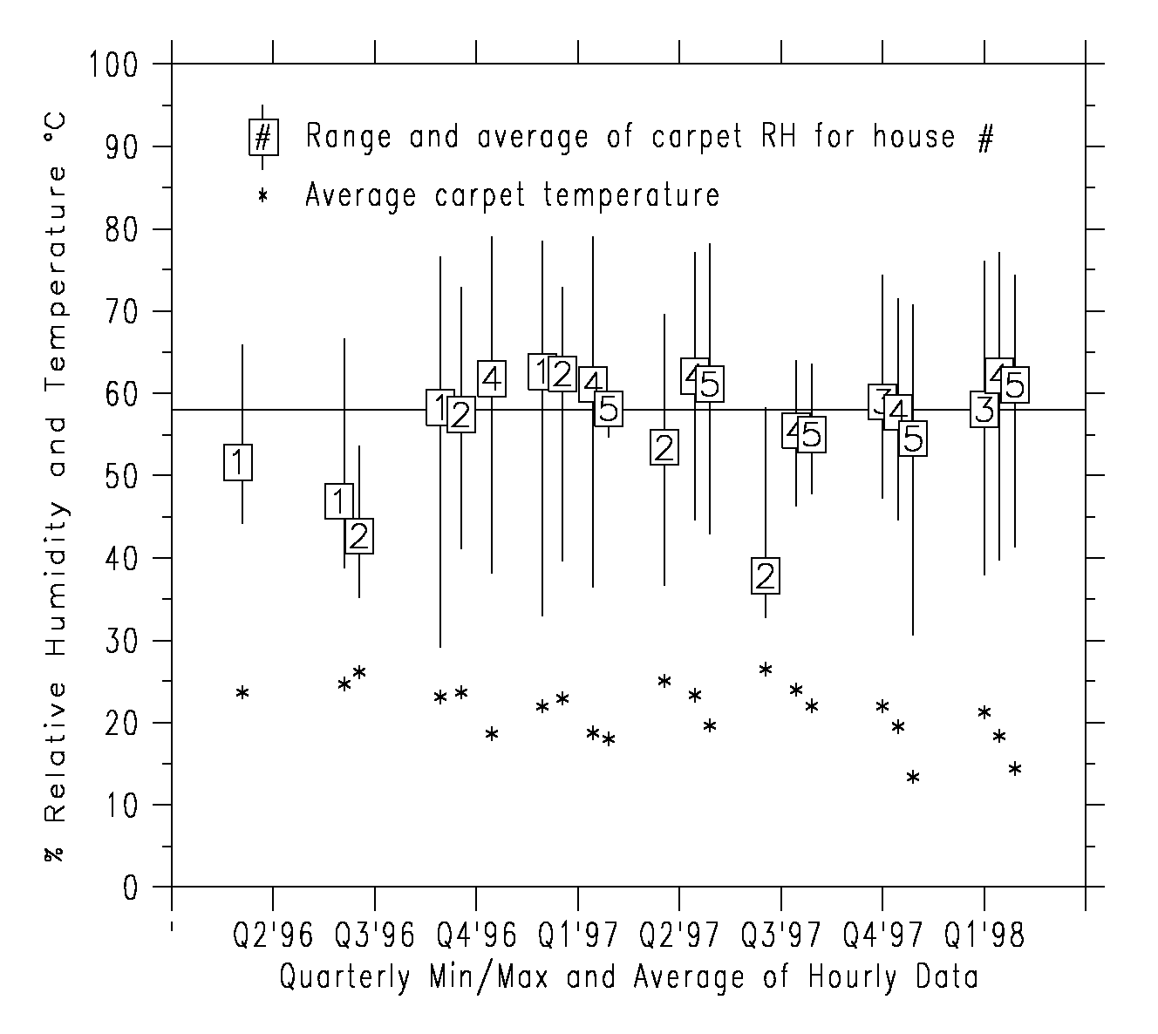
Figure 1. Measured carpet level relative humidities and temperatures in five existing homes. The RH data is plotted as a vertical bar showing the range of data. The average RH value is shown as the symbol with the house number identified inside. The corresponding temperature data is shown as an asterisk. The critical equilibrium RH line for representative temperatures (58% RH @ 25ºC ⁵) is also shown.

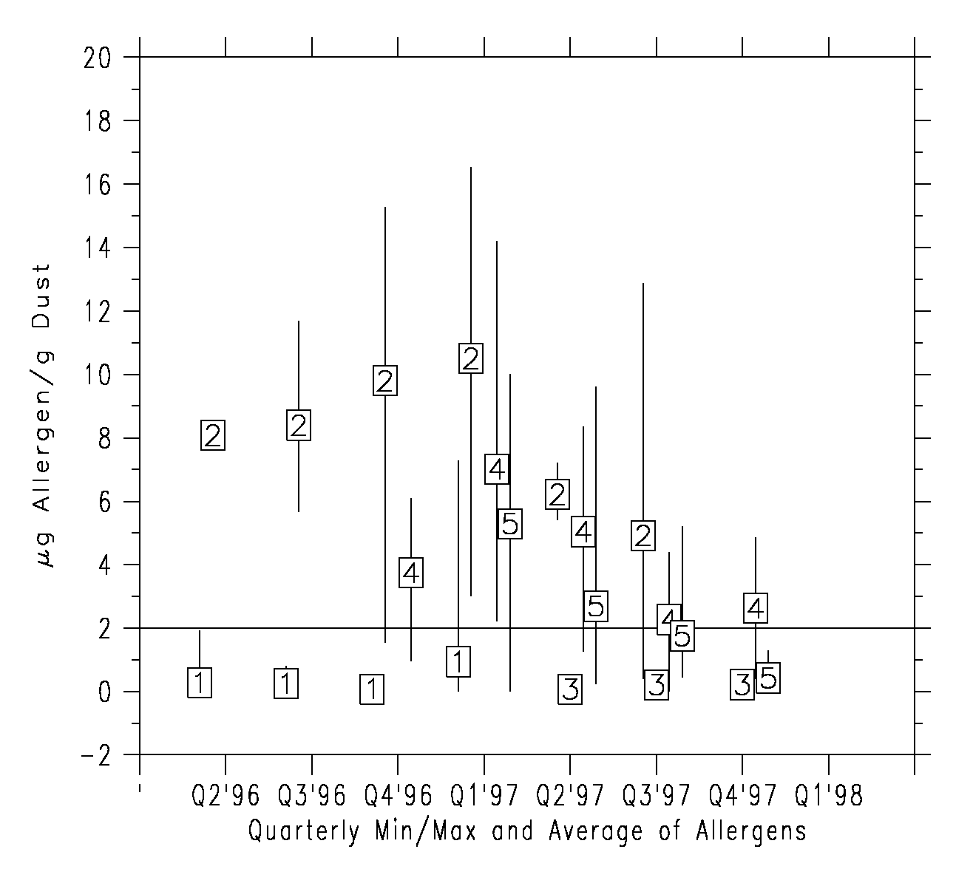
Figure 2. Measured Group1 allergens ( Der f1 + Der p1 ) in five existing homes. The y-axis plots the range and average value of the measured Group1 allergen for each house for each quarter. The critical value of 2 g/g of dust is shown as a horizontal line.
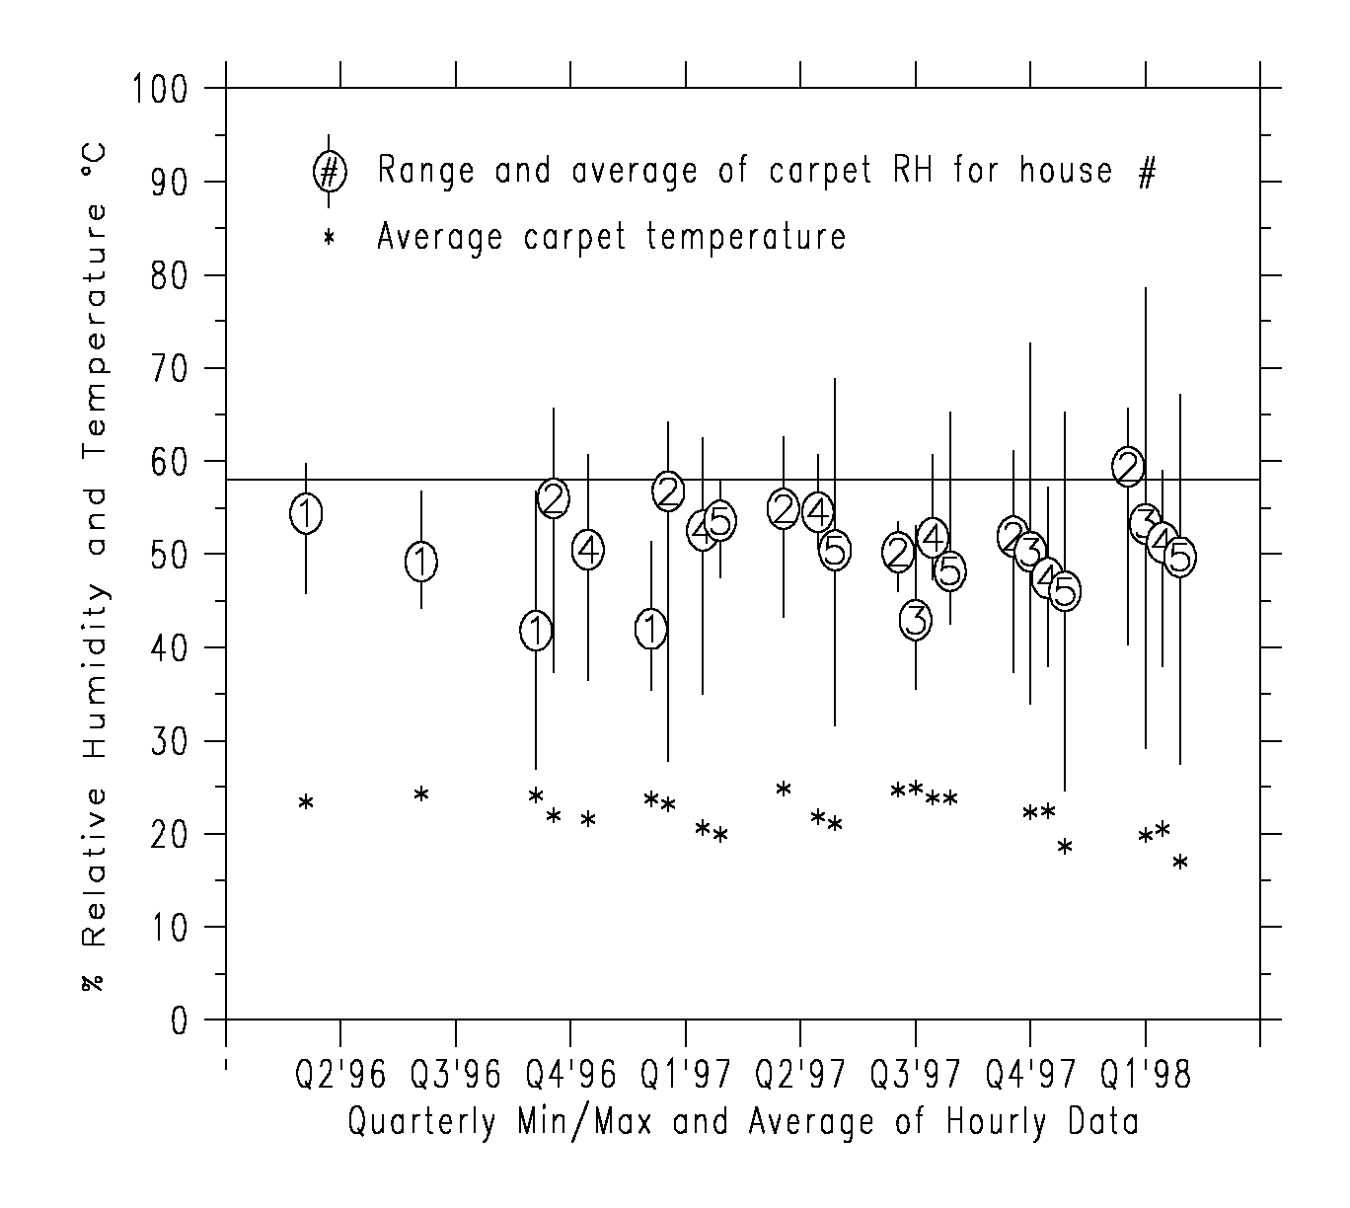
Figure 3. Measured carpet level relative humidities and temperatures in five new homes.
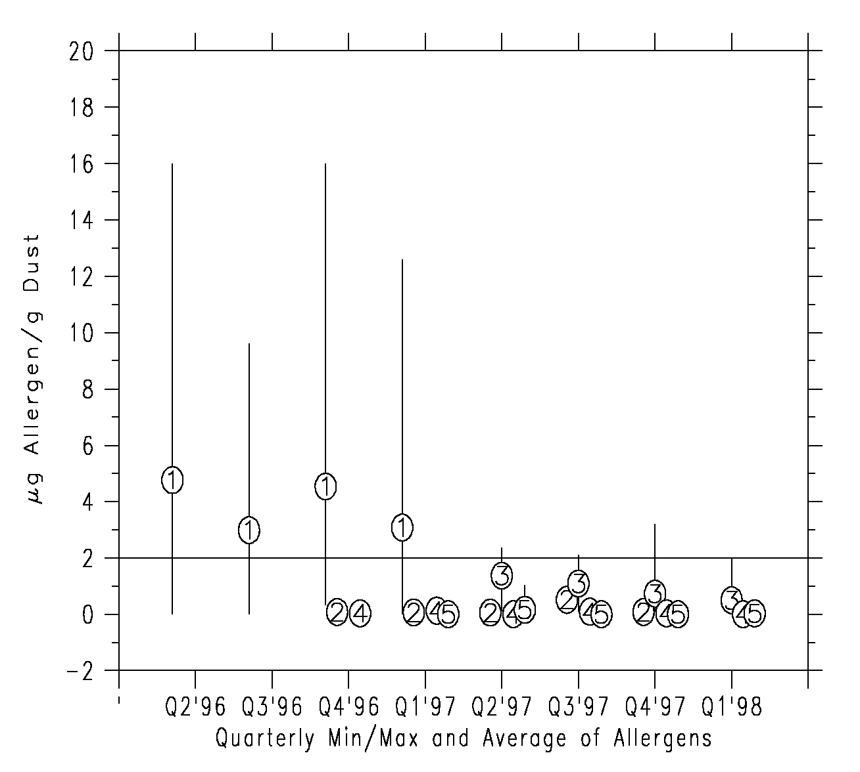
Figure 4. Measured Group1 allergens in five new homes.

