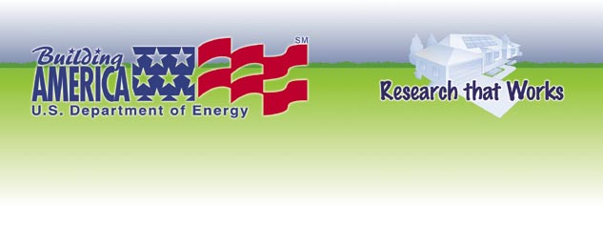

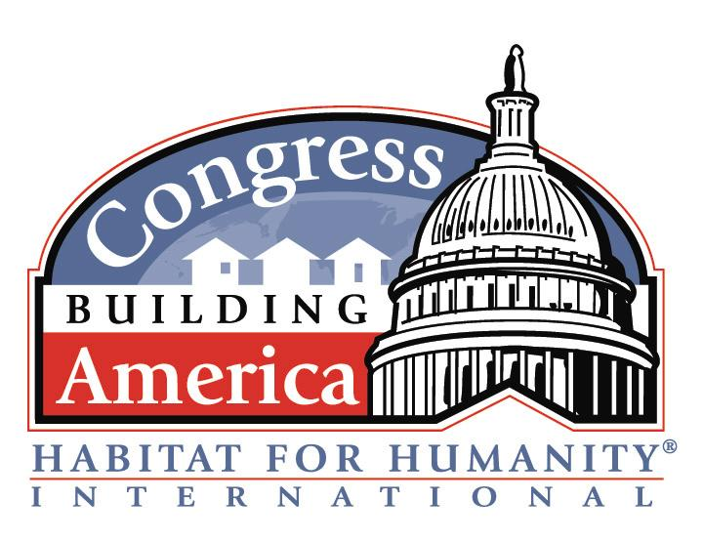
Building Technologies Program
Bringing you a prosperous future where energy is clean, abundant, reliable, and affordable
www.buildingamerica.gov
For more information about the DOE’s Building America Program and our partnership with Habitat for Humanity, contact Janet McIlvaine, Building America liaison to Habitat for Humanity at (321) 638-1434 or via email at janet@fsec.ucf.edu (please include “CBA Affiliate” in your subject line).
Habitat Goal: Eliminate poverty housing.
Building America Goal: Improve Durability, Comfort, IAQ, and energy efficiency through systems engineering.
To eliminate future poverty housing, the homes built today need to last for generations. They need to resist the decaying affects of weather and occupancy that slowly erode the safety, indoor air quality, durability, and comfort of even simple decent houses. Building America’s systems engineering approach helps builders implement climate specific building science details that work together. These considerations will help new housing stand up to the test of time…providing safety, good indoor air quality, durability, and comfort for years to come.
Habitat Goal: Build affordable houses.
Building America Goal: Greater annual affordability through energy efficiency.
Building America’s Habitat partners often say they are motivated by a desire to build houses that are affordable to live in as well as affordable to buy. We will help your affiliate identify strategies to reach Energy Star and beyond that to a goal of 30-40% energy savings with little or no increase in cost and no loss of comfort. But we know that you need to introduce changes slowly and that all recommendations need to be volunteer friendly, available in today’s market place, proven cost-effective, and not put a maintenance burden on your homeowners.
General Talking Points
- U.S. Department of Energy’s Building America Program
- Researchers offering technical assistance to all CBA affiliates
- DOE’s Building America program supports Habitat’s goals (see specifics below)
- Affordable houses are: Affordable to build, buy, and live in.
- DOE Researchers help builders make informed choices about energy efficiency, indoor air quality, moisture management, and durability.
Talking Points
- Affordable houses are: Affordable to build. Affordable to buy. Affordable to live in.
- DOE Researchers help affiliates strive for a 30-40% energy savings goal.
- Little or no increase in first cost.
- Attention to detail is something that Habitat volunteers take pride in - and that plays a major role in achieving this goal.
Talking Points
- To eliminate poverty housing, today’s new homes need to last for generations.
- DOE Researchers work with builders, like Habitat, to make informed choices about indoor air quality, moisture management, and durability.
- DOE researchers help builders, like Habitat, make sure that all the systems of the house are working together to create a healthy, comfortable environment with lower energy bills at about the cost as conventional construction.

Shared Goals and Talking Points
DOE Building America Partnership with CBA Habitat Affiliates

