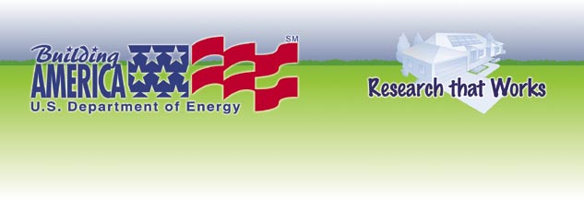
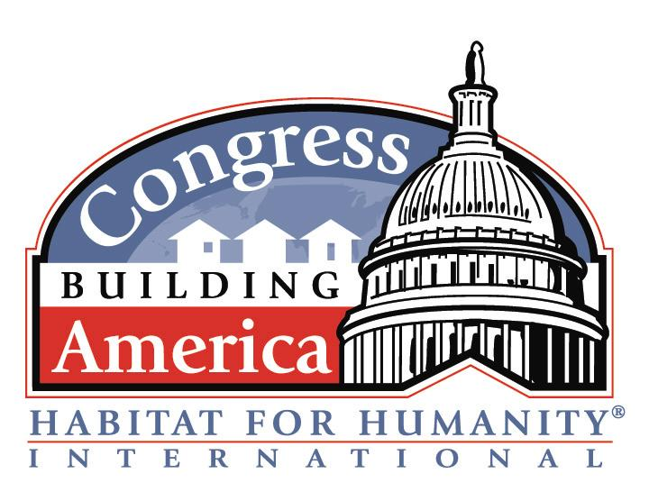
www.buildingamerica.gov
Shared Goals –Technical Assistance Discussion
DOE Building America Partnership with CBA Habitat Affiliates
The U.S. Department of Energy’s Building America Program is offering technical assistance to all CBA affiliates in supports Habitat’s goals (see specifics below) to build affordable housing and eliminate poverty housing. DOE Researchers provide the home building industry with climate specific energy efficiency and building science technical resources to help builders make informed choices about energy efficiency, indoor air quality, moisture management, and durability. Building America will also help Habitat’s CBA affiliates promote the topic of energy efficiency as an affordable housing issue with partnering members of congress.

Habitat Goal: Build affordable houses.
Building America Goal: Greater annual affordability through energy efficiency.
Building America’s Habitat partners often say they are motivated by a desire to build houses that are affordable to live in as well as affordable to buy. We will help your affiliate identify strategies to reach Energy Star and beyond that to a goal of 30-40% energy savings with little or no increase in cost and no loss of comfort. But we know that you need to introduce changes slowly and that all recommendations need to be volunteer friendly, available in today’s market place, proven cost-effective, and not put a maintenance burden on your homeowners.
Technical Assistance: You will receive a climate based package of energy efficiency improvements for achieving 30% whole house energy use savings. Your affiliate will decide which efficiency improvements make the most sense for your construction process. Packages will be a combination of equipment improvements, heating loss/gain reductions, and quality control checklists for volunteers and construction managers. Attention to detail is something that Habitat volunteers take pride in - and that plays a major role in achieving a long-term energy savings goal.
(Continued)

What to do next…
If your affiliate is interested in partnering with the U.S. Department of Energy’s Building America program, please work with your affiliate’s CBA coordinator to return the Response Form - Invitation Acceptance to initiate our collaboration or if you have questions, contact Janet McIlvaine, Building America liaison to Habitat for Humanity at (321) 638-1434 or via email at janet@fsec.ucf.edu (please include “CBA Affiliate” in your subject line).


Building Technologies Program
Bringing you a prosperous future where energy is clean, abundant, reliable, and affordable
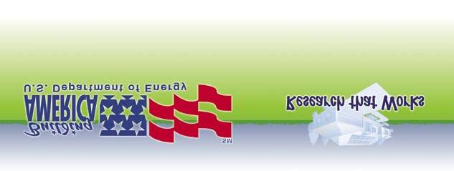
- Foundation Design
- Wall, Floor, And Ceiling/Roof Assembly Specifications
- Mechanical System Design And Construction
- Air Barrier Integrity
- Drainage Plane Integrity
- Disaster Resistance
- Indoor Air Quality Choices
- Moisture Control Strategies
Visit our website at www.buildingamerica.gov, see the “Affordable Housing Research” page to review case studies of what other Habitat affiliates have achieved with Building America technical assistance.

Affordable housing = Affordable to build. Affordable to buy. Affordable to live in.
Some affiliates will be eligible for more personalized interaction with Building America researchers and our partners. For example, we may provide your affiliate with a package of improvements developed from YOUR floor plans. Or we may be able to arrange for a free duct leakage test from someone in your region.
Habitat Goal: Eliminate poverty housing.
DOE Goal: Improve Durability, Comfort, IAQ, and energy efficiency through systems engineering.
Affiliates working with Building America researchers cite the desire to build houses that last for generations in order to short circuit the poverty housing cycle. Poverty housing doesn’t start out being unlivable, but over time, the decaying affects of weather and occupancy slowing erode the safety, health, and comfort of even simple decent houses unless their builders have planned ahead.
Technical Assistance: Building America’s systems engineering approach helps builders prevent the decaying affects of rain (including blowing rain), humidity produced by cooking and bathing, aging of building material, air pressure imbalances caused by duct leakage and reduced return air paths, ground water seepage and site drainage, water intrusion from the inside and out, and the ever present influence of humans on the building envelope, equipment, and environment. DOE researchers work with builders, including Habitat affiliates, to anticipate and prevent failures related to affects of aging and weatherization. We have found that many of these considerations also impact energy use, thus systems engineering improves energy efficiency while simultaneously improving durability (as well as comfort and indoor air quality). Affiliates and researchers will review climate specific specifications for :
What to do next…
If your affiliate is interested in partnering with the U.S. Department of Energy’s Building America program, please work with your affiliate’s CBA coordinator to return the Response Form - Invitation Acceptance to initiate our collaboration or if you have questions, contact Janet McIlvaine, Building America liaison to Habitat for Humanity at (321) 638-1434 or via email at janet@fsec.ucf.edu (please include “CBA Affiliate” in your subject line).

