To: Congress Building America Partners including
Congressional Partners
Habitat for Humanity Partners
Home Energy Industry Collaborators
Habitat Affiliates interested in Technical Assistance from U.S. Department of Energy

From: Janet McIlvaine
U.S. Department of Energy’s Building America Program
Liaison to Habitat for Humanity International and Domestic HFH Affiliates

The summaries in this update give you a glimpse into the partnership between the U.S. Department of Energy and Habitat for Humanity International’s Congress Building America Project. They share a similar name and some similar goals. Partnership materials are available on line at www.bahip.org. Under “Case Studies,” look for the red, white, and blue Congress Building America logo.
For More Information
Janet McIlvaine
Building America Program
1679 Clearlake Road
Cocoa, FL 32922
321-638-1434 phone
321-638-1439 fax
janet@fsec.ucf.edu

This summer was an exciting time for the partnership between DOE’s Building America program and Habitat for Humanity International’s Congress Building America program. The Jimmy Carter Work Project swept the whole state of Michigan and was a pleasure for us to collaborate on. We conducted field tests and technical reviews with seven Michigan affiliates this year.

Your partnership is deeply valued as we work with the nation’s construction industry toward cost-effectively building homes that are 30-50% more energy efficient and made to last for generations. If your affiliate would like to partner with DOE, please send an email to me at janet@fsec.ucf.edu and we will get the ball rolling. Though we have been focusing this year on Congress Building America affiliates, this offer is (and has been for many years) open to all Habitat affiliates.

P.S. If you’d like an electronic copy of this material (links are easier to follow), email Janet McIlvaine at janet@fsec.ucf.edu and include “Habitat” in the subject line.

DOE-CBA Partnership Briefs --------------------------------

DOE’s Building America Program Kicks off Partnership with Habitat for Humanity International’s Congress Building America Program.
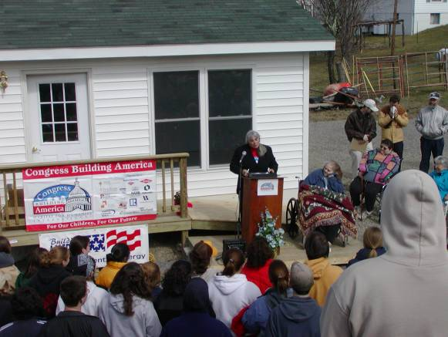
College students participating in HFHI’s Collegiate Challenge spent their Spring Break finishing the first CBA house built in West Virginia. They look on as DOE’s Building America program kicks off it’s partnership with Habitat’s Congress Building America program in March.
DOE’s Building America Program has been working with Habitat affiliates for over a decade and rededicating resources to the partnership, specifically reaching out to those affiliates working with members of U.S. Congress through HFHI’s Congress Building America program. With such similar names, perhaps the partnership was inevitable. Announcing the partnership at the dedication of the CBA home built by Almost Heaven HFH in Franklin (WV) with Congress Woman Shelley Moore Capito, Janet McIlvaine called the partnership a natural alliance, citing shared goals of making housing more affordable through energy efficiency while improving durability, indoor air quality, and comfort.

Building America will conduct a “technical review” with each of the anticipated 100 CBA affiliates this year focusing on moisture management, energy efficiency, ventilation, and indoor air quality. This type of technical review has been conducted with many HFH affiliates and is available as funds and resources permit to all HFH affiliates.

2005 Jimmy Carter Work Project
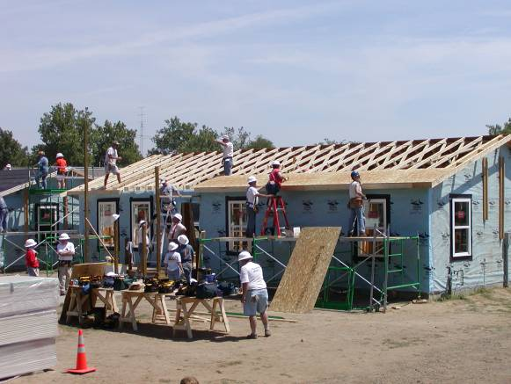
DOE-Building America researchers were on hand at the 2005 Jimmy Carter Work Project at the Benton Harbor (MI) site to work with a team of volunteers and staff on the energy, indoor air quality, and durability specifications including air sealing, insulation, and duct sealing details. After the week long blitz, the researchers tested all 25 houses in the new community, finding that all met or exceeded the air tightness target. All of the homes were rated in the weeks following the build and each is a certified Energy Star home. A case study of these homes, built with high efficiency sealed combustion gas furnaces, high performance windows, and conditioned crawl spaces will be made available this fall at http://www.fsec.ucf.edu/bldg/baihp/casestud/hfh_partner/index.htm

Michigan CBA Affiliates
HFH affiliates rallied to complete projects throughout Michigan during the June JCWP and DOE-Building America researchers visited six of them to conduct a field evaluation of their building science, indoor air quality, energy efficiency, and durability detailing.

- Michigan HFH (state organization)
- Blue Water HFH (MI)
- Harbor HFH (MI)
- Kalamazoo HFH (MI)
- Lakeshore HFH (MI)
- Lansing HFH (MI)
- Monroe County HFH (MI)

Researchers saw a wide variety of foundation systems; affiliates are striving to implement several energy efficient basement wall systems as well as the conditioned crawl space idea. Trip reports describing each field visit will be available on the website soon.
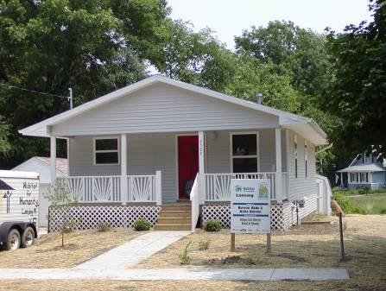
Lansing HFH
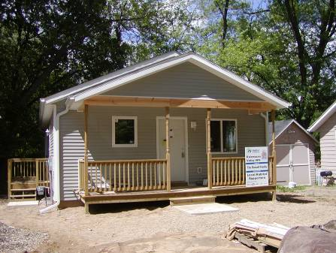
Kalamazoo HFH

Secretary of Energy visits Metro Denver HFH
Samuel Bodman, Secretary of the U.S. Department of Energy, visited the Metro Denver affiliate to see their completed Zero Energy Home built in collaboration with DOE’s National Renewable Energy Lab. From DOE’s website:
June 13, 2005
Energy Secretary Bodman Visits "Net-Zero Energy Home" Near Denver
Secretary of Energy Samuel W. Bodman visited Habitat for Humanity's first "true net-zero energy home" in a suburb of Denver, Colorado, on June 13th. The home, which is currently under construction, will be super-insulated, very tightly constructed, and designed for passive solar gain to reduce heating loads. In addition, a heat-recovery ventilation system will assure indoor air quality while recovering ventilation air thermal energy. To meet its energy needs, the home will be equipped with a solar water heating system and a grid-connected 4-kilowatt solar power system, sized to produce excess energy in the summer to balance out winter consumption, leading to net zero annual energy consumption.

"The Habitat for Humanity Zero Energy Home is a glimpse into the future of home construction in America," said Secretary Bodman. "Inefficient buildings and homes waste a tremendous amount of energy. Home energy efficiency can save families money by reducing energy consumption."

Habitat for Humanity is building the "true net-zero energy" home with technical assistance from DOE's Building America Program and National Renewable Energy Laboratory. Habitat plans to adopt many of the techniques used in this home into its standard construction practices. See the DOE press release and the Building America Web site.
Zero Energy Habitat Houses
In addition to Metro Denver HFH, Loudon County HFH in Lenoir City (TN) has built several SIP houses with bells and whistles that add up to nearly zero net energy use in collaboration with DOE’s Oak Ridge National Lab. The homes are monitored using a sophisticated rig of sensors that record not only energy use but also comfort conditions like temperature and relative humidity to verify that comfort is not sacrificed in the name of saving energy. The whole idea of zero energy houses is to first reduce the energy need of the house by 70% and then to provide the remaining 30% of energy needs with on-site power production.

The Denver and Lenoir City projects set an example and a mark of amazing achievement, but DOE is not expecting most partnering HFH affiliates to aim for that mark. Rather, we would like to work with affiliates aiming for 30-50% whole house energy savings. DOE’s Building America project has demonstrated cost effective ways to achieve 30% whole savings and scores of HFH affiliates are building to Energy Star standards which equal at least a 30% savings in heating, cooling, and water heating.

If your affiliate would like to work toward these goals, Building America researchers are available to point you in the right direction. Send an email to Janet McIlvaine at janet@fsec.ucf.edu with “Habitat” in the subject line and check out these online resources:

  - Building America Affordable Housing Research http://www.eere.energy.gov/buildings/building_america/affordable_housing.html
  - CBA-BA Partnership materials http://www.fsec.ucf.edu/bldg/baihp/casestud/hfh_partner/index.htm

Other HFH affiliates currently receiving technical assistance from DOE’s Building America Program:

- Indian River County HFH (FL)
- Lakeland (FL) HFH
- South Brevard HFH (FL)
- South Puget Sound HFH (WA)
- Space Coast HFH (FL)
- Arundel County HFH (MD)

If your affiliate should be on this list, please let us know!

Homework Assignments
1. Energy Features List: If your affiliate doesn’t have a list of the energy features you build, it’s time to create one. To start with, include the insulation values for floor, walls, and ceiling; window description (i.e. double pane low-E) and the U-value and solar heat gain coefficient (SHGC) of the windows if you can get them; the fuel and efficiency of your heating, cooling, and water heating systems; window to floor area ratio; and anything else you do to save your homeowners energy such as ceiling fans, window shading, or programmable thermostats.

2. Base Energy Use: Work with some of your recent homeowners to determine about what it’s costing to run your houses for a year. Approximately 40% of that total is used for heating and cooling.

3. Set an Energy Saving Goal: Once you have agreement from everyone on what your basic energy features are and how much energy your homes use, ask each committee to review and discuss whether or not this level of energy burden is acceptable. If not, set a goal. Now you’re ready to work with Building America to achieve it!

