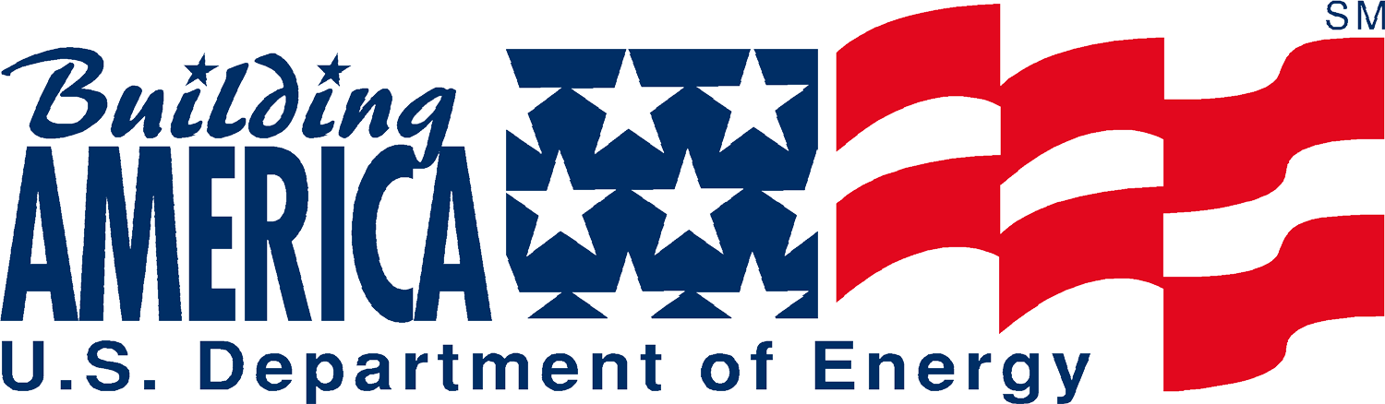

May 26, 2005

Dear Congress Building America Coordinators,

As a benefit of participating in Habitat for Humanity International’s Congress Building America (CBA) program, the U. S. Department of Energy’s Building America program extends an offer for technical assistance and review of the details in your design and construction process that influence:

- Safety (carbon monoxide control)
- Health (indoor air quality, mold prevention, humidity control, ventilation)
- Durability (moisture control, air and vapor barriers)
- Energy Efficiency (heat gain/loss, duct leakage, heating/cooling system efficiency)
- Comfort (humidity control, duct leakage, and return air balance)

In addition to this technical assistance, we will support your CBA effort in three ways:

- Press Release Materials - about your participation with DOE’s Building America program
- Letter(s) in Praise of your excellent efforts (we will send directly to your member or to you for passing along)
- Certificate of Recognition to be presented at the dedication or ground breaking of your CBA house – one for the affiliate, one for the congressional member – see enclosed samples
- On-site demonstration of energy testing may be available for your congress person’s site visit

We think this opportunity to conduct a guided technical review serves Habitat goals and we are looking forward to working with all of the CBA affiliates as we have worked with Habitat affiliates for the past 10 years. Check out some of work online at www.buildingamerica.gov, see the “Affordable Housing Research” page to view what some Habitat affiliates have achieved with Building America technical assistance.

Please review the materials under Affiliate Package 1 on our website http://www.fsec.ucf.edu/bldg/baihp/casestud/hfh_partner/index.htm and return the Response Form to initiate your affiliate’s collaboration with the Department of Energy’s Building America Program.

Sincerely,

Janet McIlvaine
U.S. Department of Energy’s Building America Program
Liaison to Habitat for Humanity
321-638-1434
321-638-1439
janet@fec.ucf.edu (please make subject line “CBA Affiliate”)

