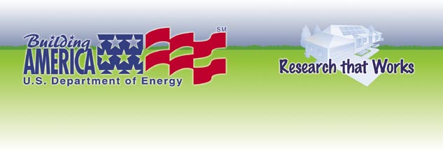
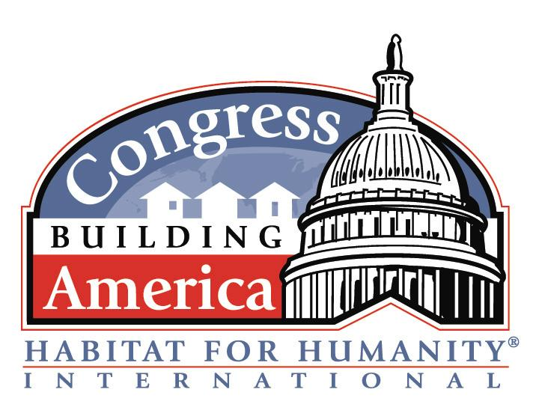
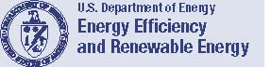
- Invitation to Participate -
DOE Building America Partnership with CBA Habitat Affiliates
The U. S. Department of Energy’s Building America program extends this invitation to all CBA affiliates to participate in a technical assistance assessment and review of the details in your design and construction process that influence:
- Safety (carbon monoxide control)
- Indoor Air Quality (mold prevention, humidity control, ventilation)
- Durability (moisture control, air and vapor barriers)
- Energy Efficiency (heat gain/loss, duct leakage, heating/cooling system efficiency)
- Comfort (humidity control, duct leakage, and return air balance)
In addition to this technical assistance, we will support your CBA effort in four ways:
- Press Release Materials about your participation with DOE’s Building America program
- Letter(s) of Commendation of your excellent efforts - sent to your congress member and to you for your use with local media
- Certificates of Excellence (see enclosed samples) - to be presented at the dedication or ground breaking of your CBA house – one for the affiliate, one for the congressional member, others for energy related partners and underwriters
- CBA Day Demonstration: A DOE representative may be available during your congress person’s site visit to demonstrate energy efficiency testing and emphasize the benefit of your home’s energy, indoor air quality, and durability features.
Building America researchers use a systems engineering approach to help ensure that all the systems in a house are working together to create a healthy, comfortable environment with lower energy bills at little or no increase in first cost. Use the Invitation Acceptance card or fax back form to signal your interest.
We are looking forward to working with all of the CBA affiliates. Visit our website at www.buildingamerica.gov, see the “Affordable Housing Research” page to review case studies of what other Habitat affiliates have achieved with Building America technical assistance. We think this opportunity to conduct a guided technical review serves our mutual goals:
Building Technologies Program
Bringing you a prosperous future where energy is clean, abundant, reliable, and affordable
What to do next…
If your affiliate is interested in partnering with the U.S. Department of Energy’s Building America program, please work with your affiliate’s CBA coordinator to return the Response Form - Invitation Acceptance to initiate our collaboration or if you have questions, contact Janet McIlvaine, Building America liaison to Habitat for Humanity at (321) 638-1434 or via email at janet@fsec.ucf.edu (please include “CBA Affiliate” in your subject line).
Affordable Housing = Affordable to build. Affordable to buy. Affordable to live in.
www.buildingamerica.gov

